**UNIX File System & Permissions**

**1: Give the execute permission for the user for a file chap1.**

chmod u+x chap1

**2: Give execute permission for user, group and others for a file add.c**

chmod a+x add.c

**3: Remove the execute permission from user, give read permission to group and others for a file aa.c**

chmod u-x,g+r,o+r aa.c

**4: Give execute permission for users for a.c, kk.c, nato and myfile using single command.**

chmod u+x a.c kk.c nato myfile

**5: Change the directory to root directory. Check the system directories, like bin, etc, usr etc.**

cd /

ls -l

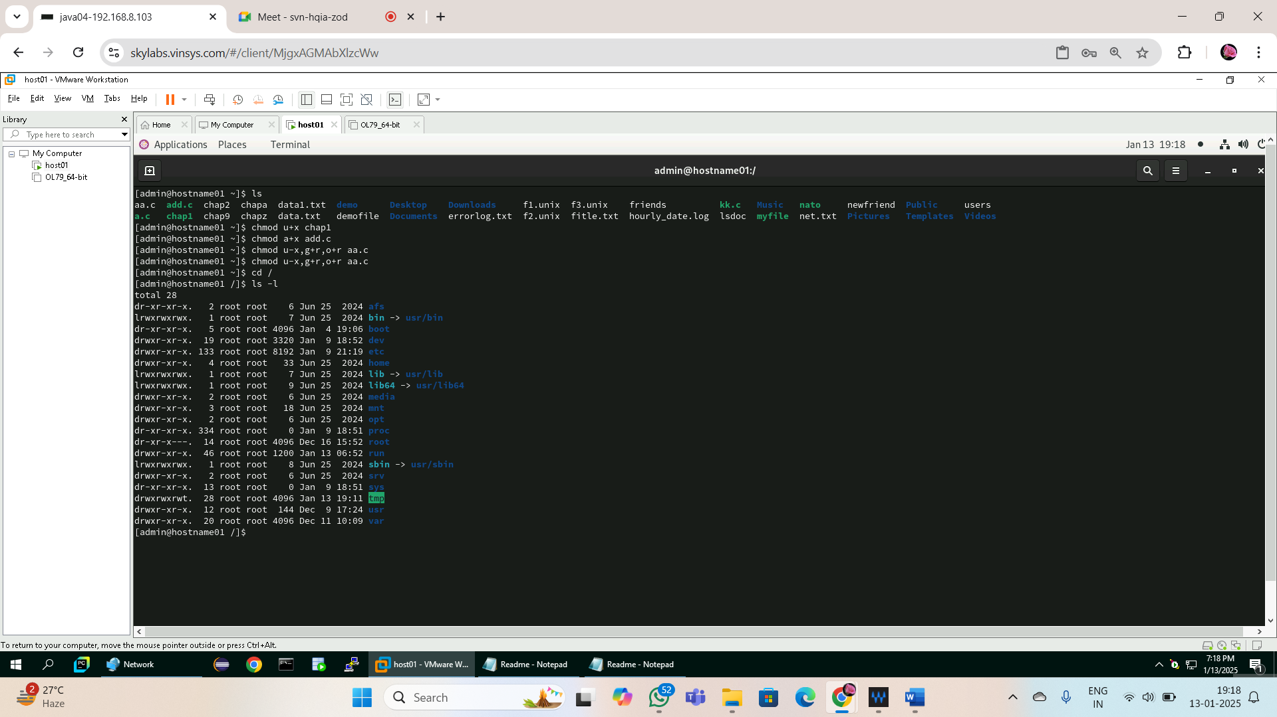

**Using Pipes and Filters**

**1: Redirect the content of the help document ls, into a file called as lsdoc.**

ls –help > lsdoc

**2: Display the content of the lsdoc page wise.**

less lsdoc

**3: Display only the first 4 lines of the lsdoc file.**

head -n 4 lsdoc

**4: Display only the last 7 lines of the file lsdoc.**

tail -n 7 lsdoc

**5: Remove the file lsdoc.**

rm lsdoc

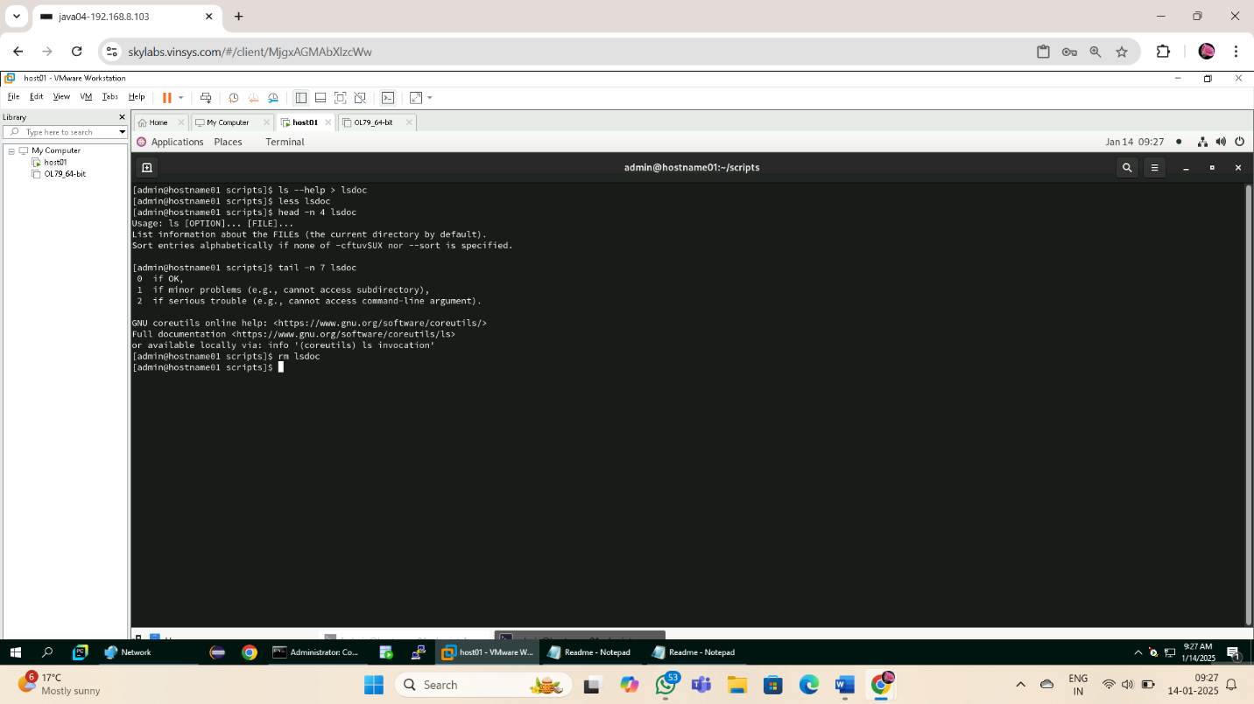

**6: There will be B’day celebration from the friends file, find how many B’day parties**

**will be held. If two of the friends have the B’date on the same day, then we will be**

**having one party on that day.**

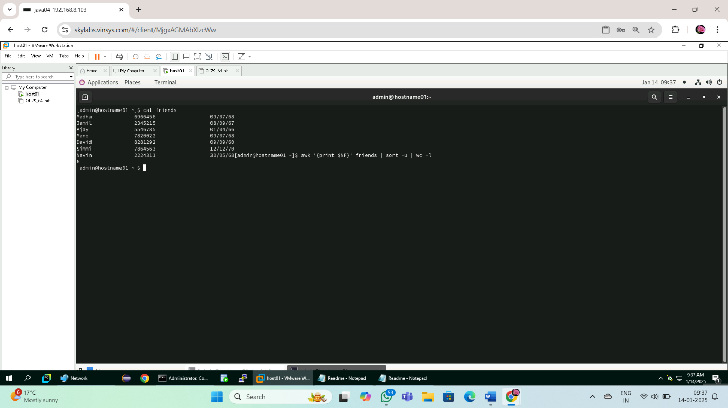

**7: Display the lines starting with Ma, in the file friends.**

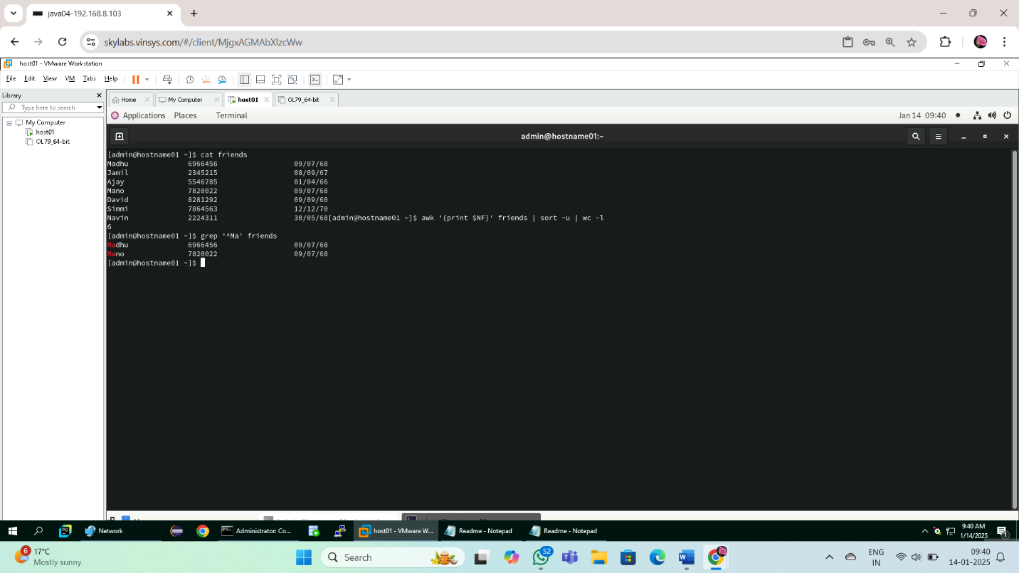

**8: Display the lines starting with Ma, ending with i or ending with id, in the file friends.**

grep -E '^Ma.*(i|id)$' friends

**9: Print all the files and the directory files from the current directory across all the sub directories, along with its path**

find . -type f -o -type d

**10: Print only the Directory files.**

find . -type d

**11: Display the files starting with chap, along with its path.**

find . -type f -name "chap*"

**12: Sort the file friends in ascending order of names.**

sort friends

**13: Display the contents of the file friends in uppercase letters.**

cat friends | tr '[:lower:]' '[:upper:]'

**14: Store the contents of your home directory in a file called dir.**

ls -l ~ > dir

**15: From the above file dir, display the file permissions and the name of the file only.**

awk '{print $1, $9}' dir

**16: From the same dir file, store only the file names in a file called files.**

awk '{print $9}' dir > files

**17: From the same dir file, store only the permissions of files in a file called perms.**

awk '{print $1}' dir > perms

**18: From the same dir file, store only the file sizes in a file called sizes.**

awk '{print $5}' dir > sizes

**19: Display the file names, sizes and permissions from your directory in that order.**

awk '{print $9, $5, $1}' dir

**20: Display the number of users working on the system.**

who | wc -l

**21: Find out the smallest file in your directory.**

ls -lS | grep '^-' | awk '{print $5, $9}' | sort -n | head -1

**22: Display the total number of lines present in the file friends.**

wc -l friends

**23: Create the following fixed record format files (with “|” delimiter between fields) with the structure given below, and populate them with relevant data use these files to solve following questions**

**emp.lst: Empid(4),Name(18),Designation(9),Dept(10),Date of Birth(8),Salary(5)**

**dept.lst: Dept.Code (2), Name (10), Head of Dept’s id(4)**

**desig.lst: Designation Abbr.(2), Name (9)**

1. **Find the record lengths of each file.**

awk -F'|' '{print length($0)}' emp.lst | sort -nr | head -1

awk -F'|' '{print length($0)}' dept.lst | sort -nr | head -1

awk -F'|' '{print length($0)}' desig.lst | sort -nr | head -1

1. **Display only the date of birth and salary of the last employee record.**

tail -1 emp.lst | awk -F'|' '{print $5, $6}'

**3. Extract only employee names and designations. (Use column specifications).**

**Save output as cfile1.**

cut -c6-23,25-33 emp.lst > cfile1

**4. Extract Emp.id, dept, dob and salary. (Use field specifications). Save output as**

**cfile2.**

cut -d'|' -f1,4,5,6 emp.lst > cfile2

**5. Fix the files cfile1 and cfile2 laterally, along with the delimiter.**

paste -d '|' cfile1 cfile2 > merged.lst

**6. Sort the emp.lst file in reverse order of Emp. Names.**

sort -t'|' -k2,2r emp.lst

**7. Sort the emp.lst file on the salary field, and store the result in file srtf.**

sort -t'|' -k6,6n emp.lst > srtf

**8. Sort the emp.ls t file on designation followed by name.**

sort -t'|' -k3,3 -k2,2 emp.lst

**9. Sort the emp.lst file on the year of birth.**

sort -t'|' -k5,5 emp.lst

**10. Find out the various designations in the employee file. Eliminate duplicate**

**listing of designations.**

cut -d'|' -f3 emp.lst | sort | uniq

**11. Find the non-repeated designation in the employee file.**

cut -d'|' -f3 emp.lst | sort | uniq -u

**12. Find the number of employees with various designations in the employee file.**

cut -d'|' -f3 emp.lst | sort | uniq -c

**13. Create a listing of the years in which employees were born in, along with**

**number of employees born in that year.**

cut -d'|' -f5 emp.lst | cut -c1-4 | sort | uniq -c

**14. Use nl command to create a code table for designations to include designation**

**code (Start with dept. code 100, and subsequently 105, 110 …).**

nl -v 100 -i 5 desig.lst > desig_codes.lst

**24: PCS has its offices at Pune, TTC and Mumbai. The employees’ data is stored**

**separately for each office. Create appropriate files (with same record structure as**

**in previous assignment) and populate with relevant data.**

1. **List details about an employee ‘Manu Sharma’ in the Mumbai office.**

grep "Manu Sharma" mumbai.lst

1. **List only the Emp.Id. And Dept. of Manu Sharma.**

grep "Manu Sharma" mumbai.lst | cut -d'|' -f1,4

1. **List details of all managers in all offices. (O/P should not contain file names.).**

cat pune.lst ttc.lst mumbai.lst | grep "|Manager|"

1. **Find the number of S.E. in each office.**

echo "Pune Office: $(grep "|S.E.|" pune.lst | wc -l)"

echo "TTC Office: $(grep "|S.E.|" ttc.lst | wc -l)"

echo "Mumbai Office: $(grep "|S.E.|" mumbai.lst | wc -l)"

**5. List only the Line Numbers and Employee names of employees in ‘H/W’ in**

**Pune file.**

grep -n "|H/W|" pune.lst | cut -d'|' -f1,2

**6. Obtain a listing of all employees other than those in ‘HR’ in the Mumbai file**

**and save contents in a file ‘nonhr’.**

grep -v "|HR|" mumbai.lst > nonhr

**7. Find the name and designation of the youngest person who is not a manager.**

grep -v "|Manager|" pune.lst ttc.lst mumbai.lst | sort -t'|' -k5,5r | head -1 | cut -d'|' -f2,3

**8. Display only the filename(s) in which details of employee by the name**

**‘Seema Sharma’ can be found.**

grep -l "Seema Sharma" pune.lst ttc.lst mumbai.lst

**9. Locate the lines containing saxena and saksena in the Mumbai office.**

grep -iE "saxena|saksena" mumbai.lst

**10. Find the number of managers who earn between 50000 and 99999 in the Pune**

**office.**

awk -F'|' '$3=="Manager" && $6>=50000 && $6<=99999' pune.lst | wc -l

**11. List names of employees whose id is in the range 2000 – 2999: in Pune**

**Office; in all offices.**

awk -F'|' '$1>=2000 && $1<=2999 {print $2}' pune.lst

awk -F'|' '$1>=2000 && $1<=2999 {print $2}' pune.lst ttc.lst mumbai.lst

**12. Locate people having same month of birth as current month in Pune office.**

grep "|$(date +%m)|" pune.lst

**13. List details of all employees other than those of HR and Admin in file F1.**

grep -vE "|HR|Admin|" F1

**14. Locate for all Dwivedi, Trivedi, Chaturvedi in Pune file.**

grep -E "Dwivedi|Trivedi|Chaturvedi" pune.lst

**15. Obtain a list of people in HR, Admin and Recr. depts. sorted in reverse order**

**of the dept.**

grep -E "|HR|Admin|Recr|" pune.lst ttc.lst mumbai.lst | sort -t'|' -k4,4r

**25: Write a command sequence that prints out date information in this order: time,**

**day of week, day number, month, year :**

**13:44:42 IST Sun 16 Sept 1994**

date +"%T %Z %a %d %b %Y"

**26: Write a command sequence that prints the names of the files in the current**

**directory in the descending order of number of links.**

ls -l | sort -k2,2nr

**27: Write a command sequence that prints only names of files in current working**

**directory in alphabetical order.**

ls -p | grep -v / | sort

**28: Write a command sequence to print names and sizes of all the files in current**

**working directory in order of size.**

ls -lS | awk '{print $9, $5}'

**29: Determine the latest file updated by the user.**

ls -lt | awk 'NR==2 {print $9}'